**Repository Data**

|  |  |
| --- | --- |
| **Table of contents** | |
| **Video S1** | Video file for 3D reconstruction of crown root section of *Piper methysticum* by μCT analysis |
| **Video S2** | Video file for 3D reconstruction of lateral root section of *Piper methysticum* by μCT analysis |
| **Figure R1** | GC-MS Total Ion chromatograms of various parts of *P. methysticum* stems |
| **Figure R2** | GC-MS Total Ion chromatograms of standards of some kava lactones found in *P. methysticum* roots |
| **Figure R3** | LC-MS Total Ion chromatograms of various parts of P. methysticum roots in positive mode. |
| **Figure R4** | LC-MS Total Ion chromatograms of various parts of *P. methysticum* stems in positive mode |
| **Figure R5** | LC-MS Total Ion chromatograms of various parts of *P. methysticum* roots in negative mode |
| **Figure R6** | LC-MS Total Ion chromatograms of various parts of *P. methysticum* stems in negative mode |
| **Figure R7** | Flowchart and settings for image processing, rendering and segmentation of μCT data with Avizo software |
| **Figure R7.1** | Screenshot of 3D rendering and surface generation protocol used for crown and lateral roots of *P. methysticum.* |
| **Figure R7.2** | Screenshot of ‘Resample’ module and its properties used prior to surface generation |
| **Figure R7.3** | Screenshot of ‘Generate Surface’ module and its properties |
| **Figure R7.4** | Screenshot of ‘Surface View’ module and its properties |
| **Figure R7.5** | Screenshot of ‘Label analysis’ module and its properties |
| **Figure R7.6** | Screenshot of ‘Segmentation Editor’ and its various functions |
| **Figure R8** | MS-MS overlay spectra and fragmentation pattern of dihydromethysticin obtained in Parallel Reaction Monitoring (PRM) MALDESI mode. |
| **Figure R9** | MS-MS overlay spectra and fragmentation pattern of desmethoxyyangonin obtained in Parallel Reaction Monitoring (PRM) MALDESI mode. |
| **File R10** | Statistical analysis data files – provided as a folder in the repository |



**Figure R1. GC-MS Total Ion chromatograms of various parts of *P. methysticum* stems.**

**A**, stem with peel (**SWP**), **B**,stem peel(**SP**), **C**,stem with no peel(**SNP**), and **D**, docasanoic acid in acetoneused as blank. The representative constituents identified are benzenepropanal (**b**), dihydromethysticin (**d**), hydrocinnamic acid (**h**), pipermethystine (**p**), and desmethoxyyangonin (**y**).



**Figure R2. GC-MS Total Ion chromatograms of standards of some kava lactones found in *P. methysticum* roots.**

**A**, three kavalactones, kavain (**k**), dihydromethysticin (**d**), desmethoxyyangonin (**y**), **B**,docosanoic acid (**i**) used as internal standard.



**Figure R3. LC-MS Total Ion chromatograms of various parts of *P. methysticum* roots** **in positive mode.**

**A**, peel of crown roots (**CRP**), **B**,crown root with no peel (**CNP**), **C**,crown root with peel (**CWP**), and **D**,lateral roots(**LR**).



**Figure R4. LC-MS Total Ion chromatograms of various parts of *P. methysticum* stems in positive mode.**

**A**, stem with peel (**SWP**), **B**,stem peel(**SP**), **C**,stem with no peel(**SNP**), and **D,** blank



**Figure R5. LC-MS Total Ion chromatograms of various parts of *P. methysticum* roots** **in negative mode. A**, peel of crown roots (**CRP**), **B**,crown root with no peel (**CNP**), **C**,crown root with peel (**CWP**) and **D**,lateral roots(**LR**)



**Figure R6. LC-MS Total Ion chromatograms of various parts of *P. methysticum* stems.**

**A**, stem with peel (**SWP**), **B**,stem peel(**SP**), **C**,stem with no peel(**SNP**), and **D,** blankin negative mode.

**Figure R7: Flowchart and settings for image processing, rendering and segmentation of μ-CT data with Avizo software**

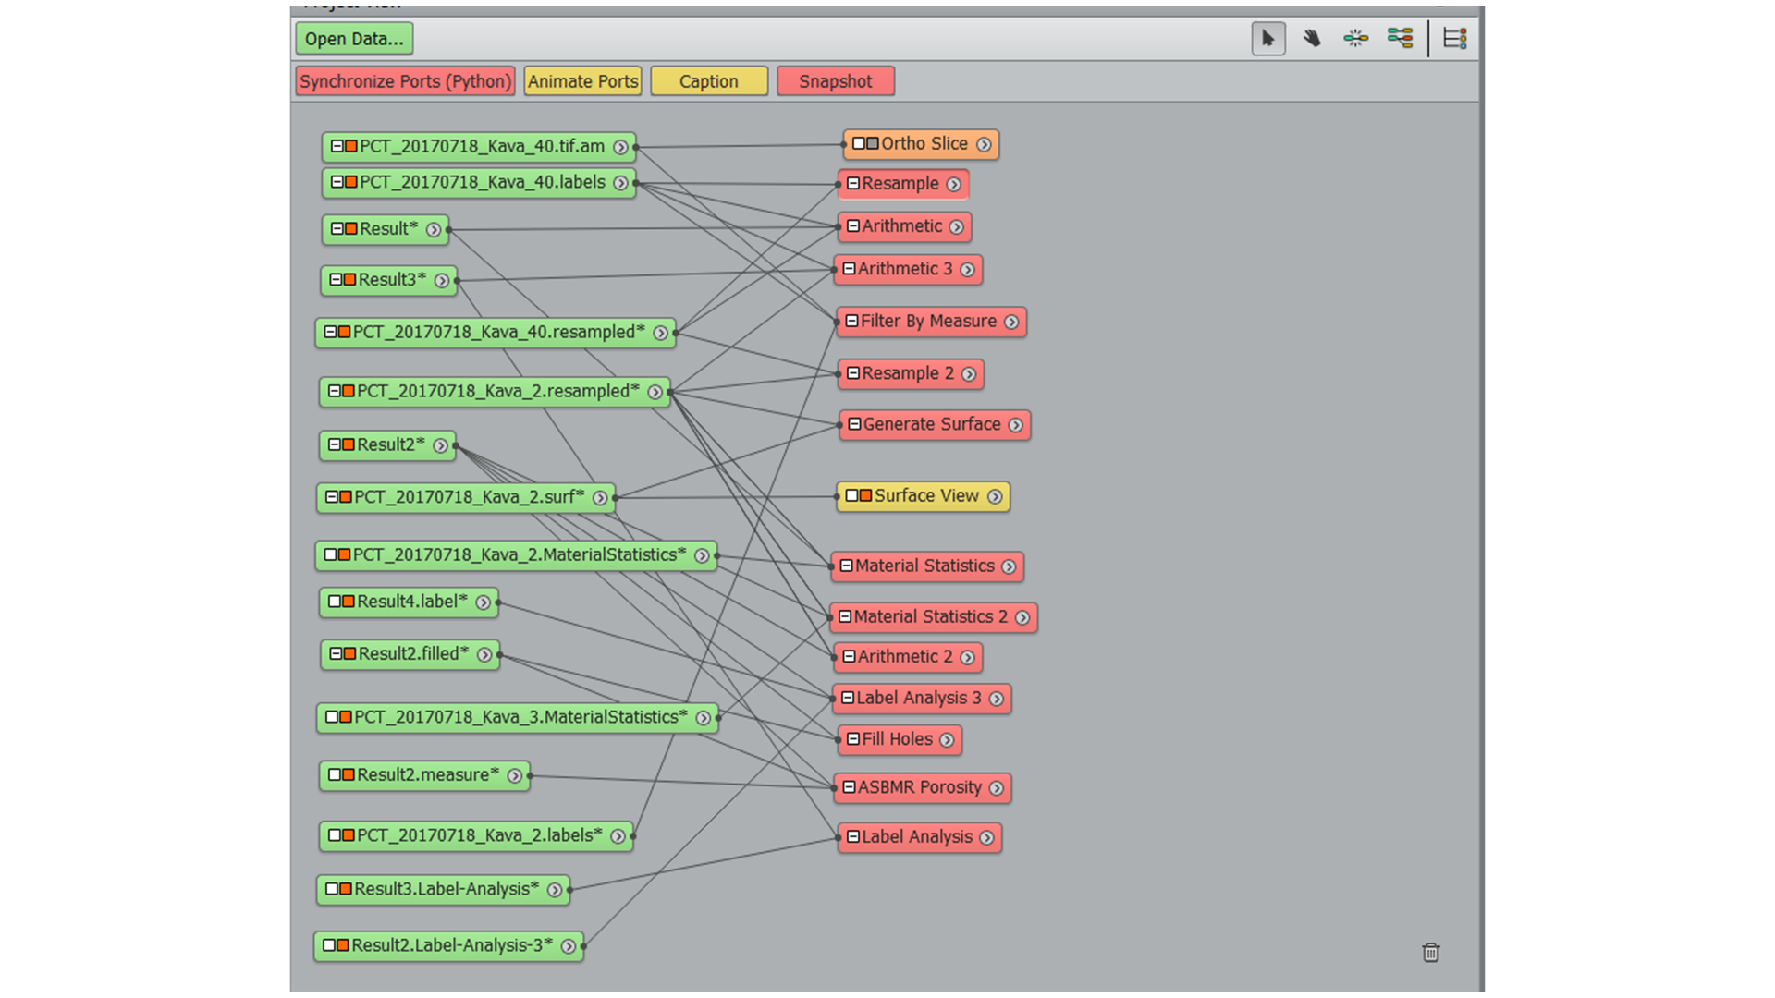

**Figure R7.1** Screenshot of 3D rendering and surface generation protocol, used for crown and lateral roots of *P. methysticum*.

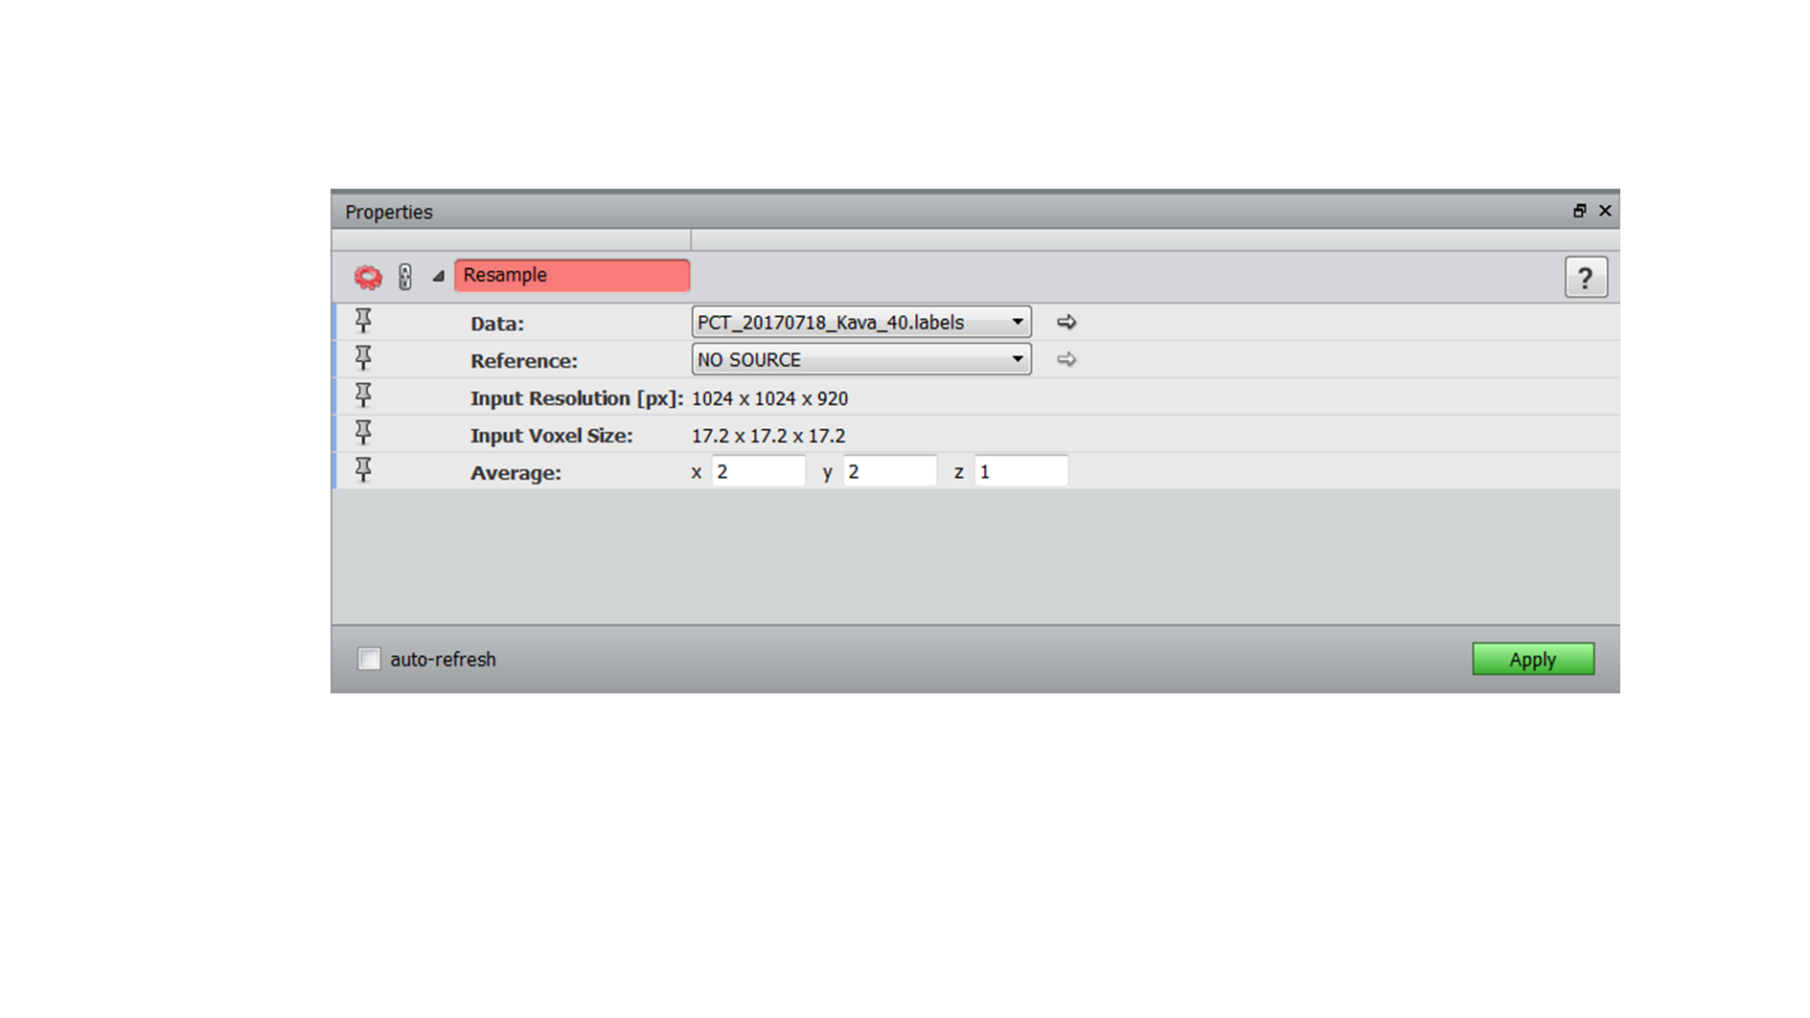

**Figure R7.2** Screenshot of ‘Resample’ module and its properties used prior to surface generation

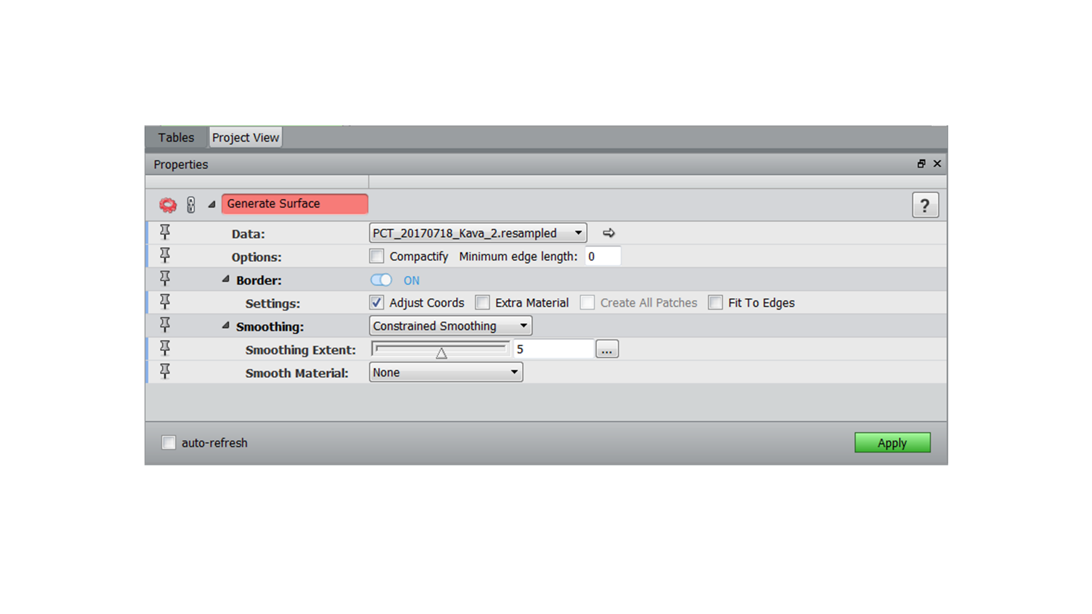

**Figure R7.3** Screenshot of ‘Generate Surface’ module and its properties

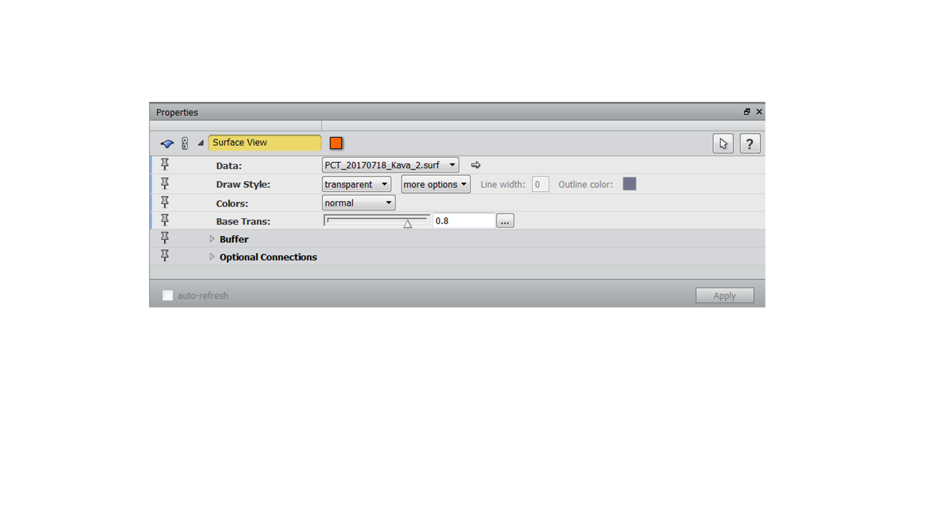

**Figure R7.4** Screenshot of ‘Surface View’ module and its properties

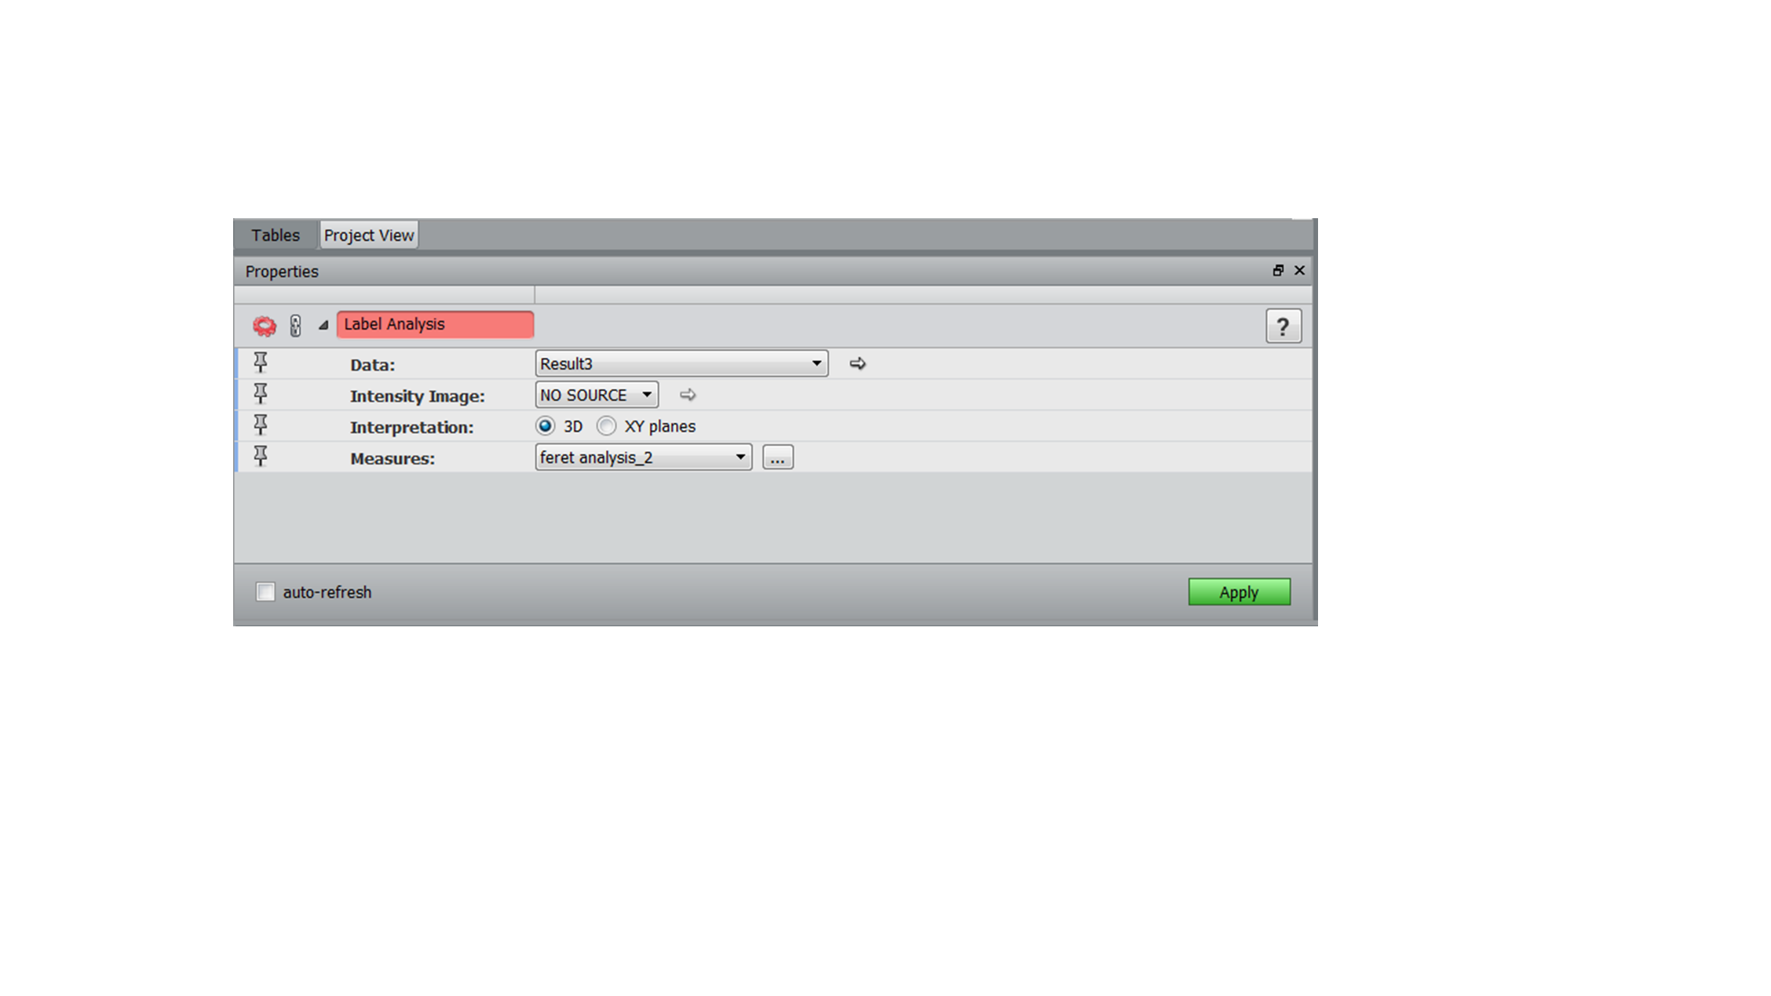

**Figure R7.5** Screenshot of ‘Label analysis’ module and its properties

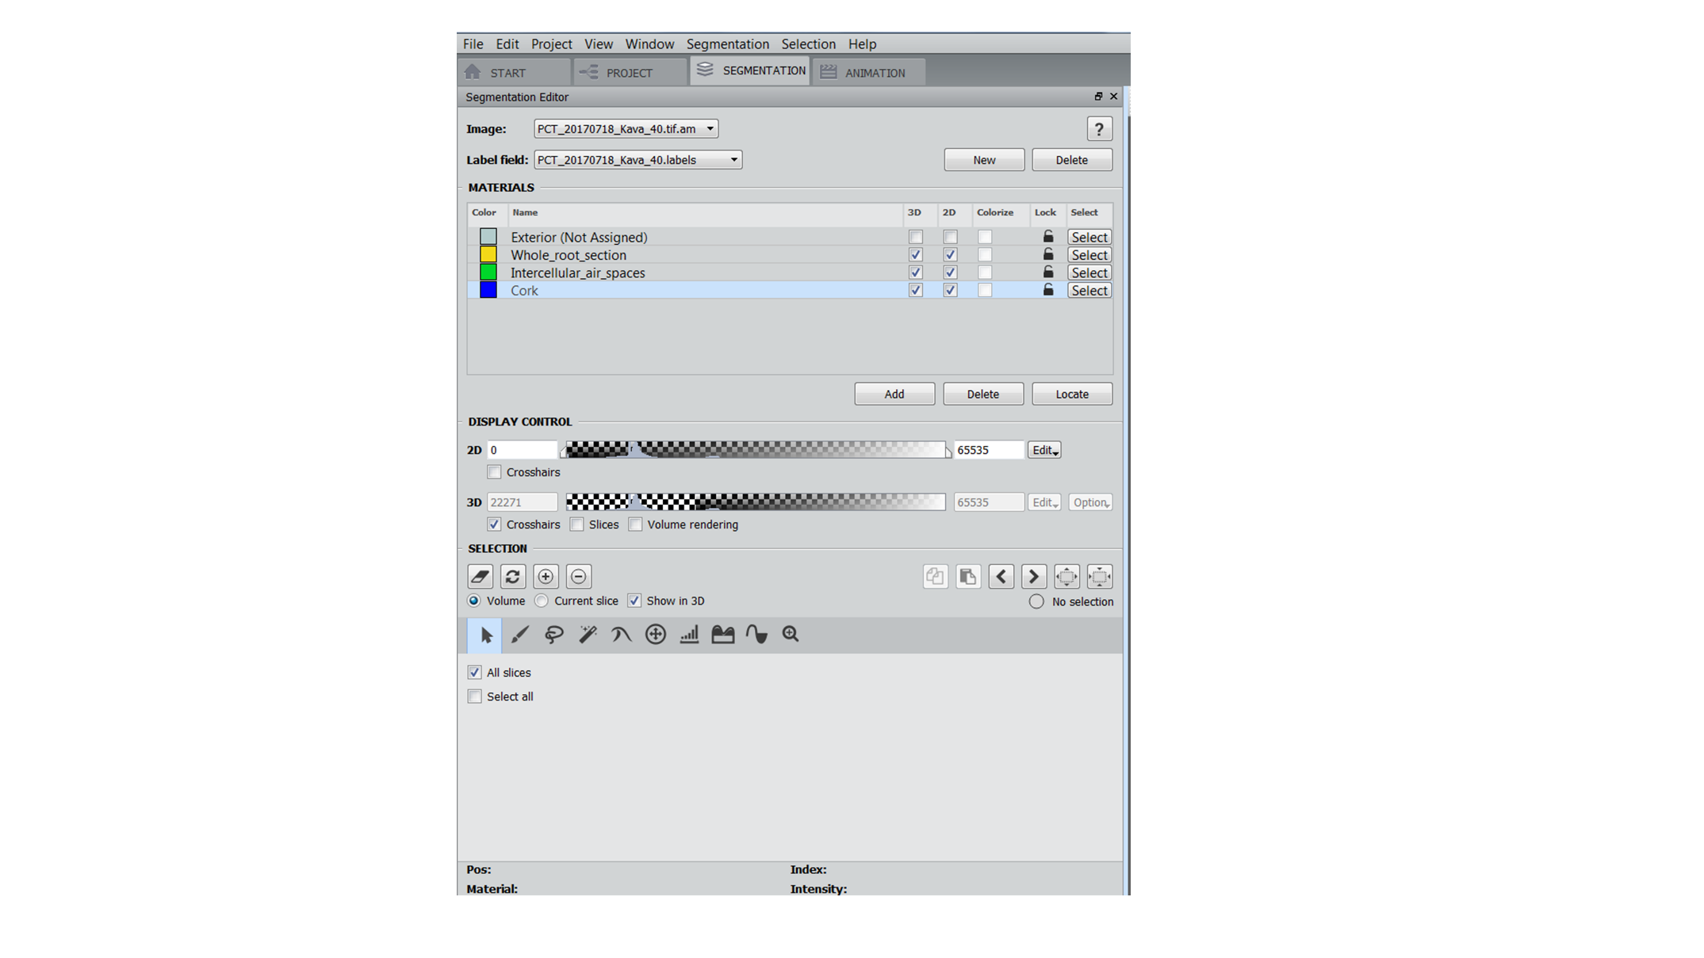

**Figure R7.6** Screenshot of ‘Segmentation Editor’ and its various functions

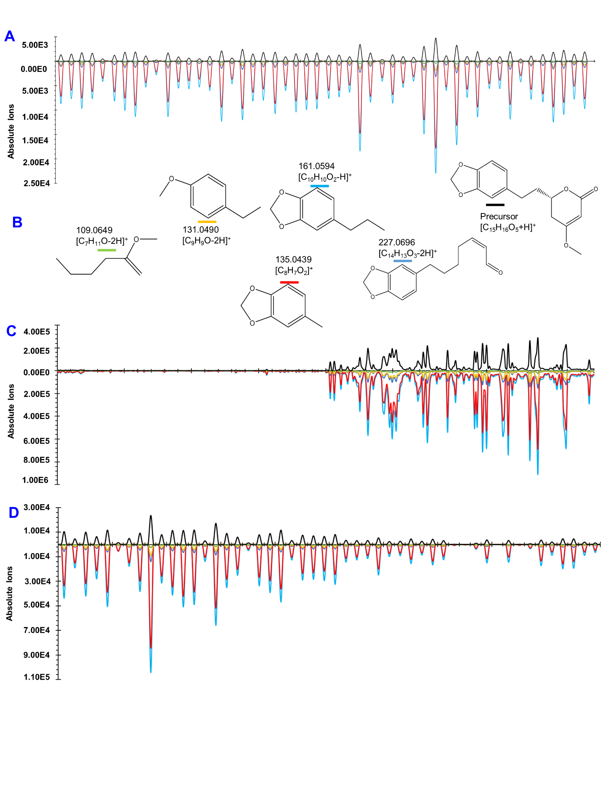

**Figure R8. MS-MS overlay spectra and fragmentation pattern of dihydromethysticin obtained in Parallel Reaction Monitoring (PRM) MALDESI mode. (A)** represent the MS-MS spectra of standard compound, **B** represents the fragmentation pattern of dihydromethysticin, **C** and **D** represent the MS-MS spectra of kavain on crown root and stem tissues, respectively.

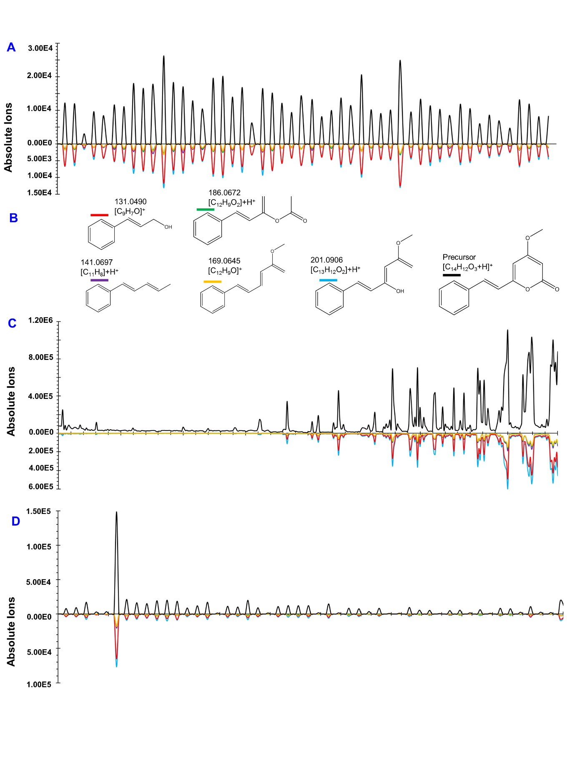

**Figure R9. MS-MS overlay spectra and fragmentation pattern of desmethoxyyangonin obtained in Parallel Reaction Monitoring (PRM) MALDESI mode. (A)** represent the MS-MS spectra of standard compound, **B** represents the fragmentation pattern of dihydromethysticin, **C** and **D** represent the MS-MS spectra of kavain on crown root and stem tissues, respectively.

**File R10. Statistical analysis data files – provided as a folder in the repository:** https://github.com/palomnyk/kava_3D_imaging_and_metabolomics